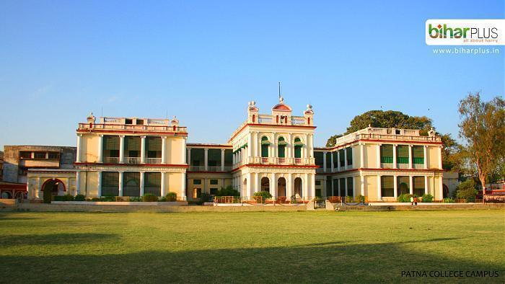

**Patna University**



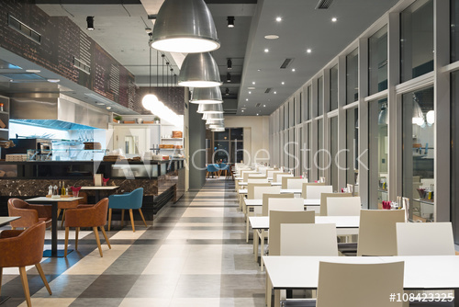

**SYNOPSIS OF**

**CANTEEN MANAGEMENT SYSTEM**

**Submitted by:-**

**Vidya Surbhi Srijan Lal Rahul Mehta**

**Roll no:-22 Roll no:-03 Roll no:-09**

B.A.(Hons) in Computer Applications

**Submitted to the Department of BCA**

**In partial fulfilment of the requirements**

**For the award of the degree, session: (2017-2020)**

**Certificate**

This is to certify that the project entitled “Canteen Management System” in Java carried out at St. Michael’s School has been submitted by **Vidya Surbhi (Roll no-22), Srijan Lal (Roll no-03), & Rahul Mehta (Roll no-09)** 3rd  year B.C.A. students of the Patna university ,towards the partial fulfilment of the requirement for the award of the Bachelor of computer application(B.C.A.) and the same has been satisfactorily carried out under the guidance of Shyamali Rani ,Software Developer(India LLP).

**Shyamali Rani Mr. Avinash Kumar**

**Project Guide Co-ordinator of department**

**B.C.A(Patna College)**

Contents

1. Acknowledgement
2. Introduction of project
3. Abstract of the Project
4. Process model used
5. Software Requirement Specification
6. Need For a new system
7. Services provided to the user
8. Function That Canteen System provide
9. Class Structure
10. Data Flow Diagram
11. Testing
12. Future Scope of the Project
13. References

**Acknowledgement**

We wish to express our deep sense of gratitude to our Project Guide Shyamali Rani for her guidance and help in completing this project.

I feel great pleasure for the completion of this project .At the very outset I would express my sincere thanks gratitude to **Mr.Avinash Kumar Vimal, HOD BCA department** for providing us an opportunity to undertake our project development at his department .I also thanks to several member of our department .I also thanks to several member of our department for their co-operation at various stage of our project development work.

I take opportunity to thanks all my friends and all people who directly or indirectly concerned with this project. I also express my gratitude to my parents who give a constant support and love throughout my life and career.

**Vidya Surbhi (Roll no-22)**

**Srijan Lal (Roll no-03)**

**Rahul Mehta (Roll no-09)**

**Introduction**

The “Canteen Management System” has been developed to override the problems prevailing in the practicing manual system. This software is supposed to eliminate and in some cases reduce the hardship faced by this existing system. Moreover this system is designed for the particular need of the school to carry out operations in a smooth and effective manner.

Every organization, whether big or small, has challenges to overcome and managing the information of Canteen,Payment,Bill,Record.Every School Canteen Management System has different School Canteen needs therefore we design exclusive canteen management system that are adopted to your managerial requirement. This is designed to assist in strategic planning, and will help us ensure that our organization is equipped with the right level of information and details for your future goal.

Objective of Project

* To override the problems prevailing in the practicing of manual system.
* Manage the information of Canteen properly.
* Manage the information of Sales, stocks.
* Generates the report on Canteen and Stocks nicely.
* Integration of all records of Item Category.
* To reduce money fraud issue by keeping update data on software every time.
* Take care of student’s health.
* Follow school canteen policy.
* Giving nutrition to students by strictly following proper food item.

**Scope of Project:**

* Smooth functioning and easy to operate.
* To facilitate students to make more healthy

food choices and to develop healthy eating habits.

* Make functioning of canteen faster.
* Provide a system where the canteen staff can fastly serve the food to students.
* User friendly software.
* Be easy to understand by the user and admin.
* Has a good interface.
* Provide monthly, yearly report.
* Total stocks, sales function are transparent.

**Abstract**

The purpose of the Canteen management system is to automate the existing manual system by the help of computerised equipment and full-fledged computer software, fulfilling their requirement, so that their valuable data/information can be stored for a longer period with easy accessing and manipulation of the same. The required software and hardware are easily available and easy to work with.

Canteen Management System, as described above, can lead to error free, secure, reliable and fast management system. It can assist the user to concentrate on other activities rather than to concentrate on record keeping. That means that one need not be distracted by information that is not relevant while being able to reach the information.

Basically the project describes how to manage for good performance and better service for the clients.

Process Model

In my project, I have used waterfall model. This model is used when requirements are well defined and reasonably stable, and in my project ‘Canteen Management System’ all the requirements are well defined.

The waterfall model, sometimes called the classic life cycle, suggests a systematic, sequential approach to software development that begins with customer specification of requirements and progresses through planning, modelling, construction and deployment, culminating in on-going support of the complete software.

I have defined activities and represented them into separated process phases. All the stages overlap and fed information to each other. It is not a simple linear model but involves a sequence of iterations of development activities.

This model is appropriate for my project as I had ample of time for designing it, so the time constraints were not there. This model generally takes more time to complete the software life cycle as when a stage completes it is signed off and development goes onto the next stage.

Requirements Specification

**Functional requirements:**

* Item name and item price is forming the primary keys of the respective tables.
* Stock, Sales and Report are only accessed by Admin on the name of security purpose.
* There will be a function of annual or monthly reporting system to show the actual profit and loss.
* While inserting values in the database, only valid values must be entered.
* Data entry is very smooth, fast and highly user friendly.
* Home Page with good UI.

**Data requirements:**

* The Canteen Management System shall be required to maintain information about orders and food.
* It shall store databases for sales, stock and coupon.
* The stock database stores information about a product name, price, date and product type.
* The sales database stores information about every coupon, date, item name, cost, coupon number, date of every coupon.
* The coupon database stores information about item name, item price, total number of sold item, and total cost of item.
* The report database show the report of every function in a table view for wider picture of all functions.

Software requirements:

|  |  |
| --- | --- |
| Name of component | Specification |
| Operating system | Windows 7 , Windows 10 |
| Language | Java 2 Runtime environment |
| Database | Oracle |
| Software development Kit | Java JDK 1.7 or Above |
| Database JDBC Driver | OJDBC connector |

Hardware requirements:

|  |  |
| --- | --- |
| Name of Component | Specification |
| Processor | Intel i3 or more |
| RAM | 2 GB or more |
| Hard disc | 500GB or more |
| Monitor | 15’’ colour or advance |
| Keyboard | Any Keyboard |
| Mouse | Any Mouse |
| Printer | In case of printing Reports |

**Need for a new system**

As we have seen , the existing system have following drawbacks which create the need of new system

1. Time consuming
2. Search challenging task
3. To take care of student’s health
4. Generating coupon is complex
5. Maintaining register is complex
6. Taking care of canteen item
7. Reporting about every function of canteen is complex.
8. Every functionality of canteen is not transparent.

**Services provided to the users**

* The Canteen Management System automates the basic canteen functions to aid in the day-to-day operations of a canteen.
* It supports functions such as ordering, stocking, the very basic functions with proper editing and updating features.
* The software aims to make the system user friendly and efficient.
* Show the information and description of Canteen and food order.
* Manage the information about food item, order record, sales and stocks on daily basis.
* Track all information and make it fully transparent way.
* Integrate all records and function of Canteen in a very user friendly and secure manner.

**Modules of Project**

* **Bill Module:** used for managing the order and bill details.
* **Item Module:** used for managing the details of food item.
* **Stock Module:** used for calculating and managing the details of stock material.

  **Sales Module**: used for managing the details of selling of item.

  **Users Module**: used for managing the users of the system.

  **Staff Module**: used for managing the details of staff.

  **Report Module**: used for managing the report of every function of system.

INPUT DATA AND VALIDATION

* All the fields such as Employee, Leave, Payment and Travel are validated and does not take invalid values.
* Avoiding errors in data
* Controlling amount of input
* Integration of all the modules in the system
* Preparation of the possible test data with all the validation checks
* Actual testing done manually
* Modification done for the errors found during testing
* Validations of user input
* Checking for the coding standard to be maintained during coding
* Testing the module with all possible test data

**THE SOFTWARE QUALITY PLAN**

* In the first step, we will select the test factors and ranked them. The selected test factors such as reliability, maintainability etc. will be placed in the matrix according to their ranks.
* The second step is for identifying the phase of the development process. The phase should be recorded in the matrix.
* The third step is that identifying the business risks of the software deliverables. The risks will be ranked into three ranks such as high, medium and low.

**ER-Diagram For Canteen Management System**

**Bill**

**Has**

**Sales**

**Stock**

**Item**

**Manage**

**User**

# **CLASS STRUCTURE**

**Fig:Level Zero DFD**

First Level DFD-Human Resource Management System

Travel Management

Data Flow Diagram

Bill Management

Sales Management

Item Management

Staff Management

User Management

Stock Management

**Fig. Level 1 DFD**

Bill Management

Item Report

Item Management

Sales Report

Sales Management

Bill Report

Stock Management

Annual Report

Staff Management

**Testing:**

* It is integral part of any system’s development life cycle without which the system developed is sure to fail and result in loss of economic and manpower investments besides user’s dissatisfaction and downfall of reputation.
* System testing is the stage of implementation, which aims at ensuring that the system works accurately and efficiently before actual operation commences. No program or system design is perfect, communication between the user and the designer is not always complete or clear. All this can result in errors.
* Another reason for system testing is its utility as a user oriented vehicle before implementation. The application system is worthless if does not meet user needs, thus the system should be tested to see whether it meets the user requirements.
* Testing here is conducted in bottom up approach as follows:
* Module testing: Here testing is done at each module level. Each case has been thoroughly tested to discover pitfalls.
* System testing: Here testing is done after all the modules have been integrated.

IMPLEMENTATION METHODOLOGY

Model View Controller or MVC as it is popularly called, is a software design pattern for developing applications. A Model View Controller pattern is made up of the following three parts:

* **Model**- This lowest level of the pattern which is responsible for maintaining data.
* **View**- This is responsible for displaying all or a portion of the data to the user.
* **Controller**-Software Code that controls the interaction between the Model and View.

MVC is popular as it isolates the application logic from the user interface layer and supports separation of concerns. Here the controller receives all requests for the application and then works with the Model to prepare any data needed by the View. The View then uses the data prepared by the controller to generate a final presentable response. The MVC abstraction can be graphically represented as follows.

**MVC (Model View Controller) Diagram**

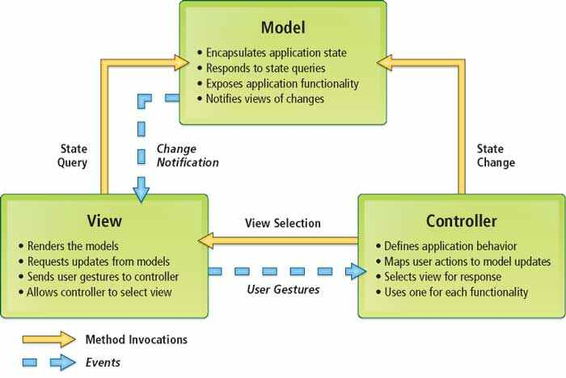

**FUTURE SCOPE OF THE PROJECT**

We can give more advance software for Canteen Management System including more facilities. Enhancements can be done to maintain all the Item, Sales, Bill, Stocks, Report and Staff.

We have left all the options open so that if there is any other future requirement in the system by the user for the enhancement of the system then it is possible to implement them. In the last we would like to thanks all the person involved in the development of the system directly or indirectly. We hope that the project will serve its purpose for which it is develop there by underlining success of process.

**LIMITATION OF THE PROJECT**

- Excel report has not been developed.

- The transactions are executed in off-line mode.

- Considerable efforts have made the software easy to operate even for the people not related to the field of computers but it is acknowledged that a layman may find it a bit problematic at the first instance.

**References And Bibliography**

* Google for problem solving
* <https://www.tutorialspoint.com/sql>
* <https://www.tutorialspoint.com/jdbc>
* <https://www.tutorialspoint.com/java>
* Database programming with JDBC and java by O’Reily.